ALAN TURING and the Bletchley Park Codebreakers.
Alan Turing was born on 23rd June 1912. He showed signs of intelligence in his primary school which his teachers recognised but they didn’t necessarily respect him knowing it. He then attended the well-known Sherborn school at the age of 13. Alan Turing started his career in the 1940’s as a scientist in the national physical laboratory. He then joined Bletchley Park to help Britain win the war.
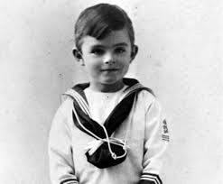
Alan Turing played an extremely important role in the second world war. He had invented a device to decrypt the German’s Enigma coding machine. His machine was called the Turing Machine, which was based at Bletchley Park. Bletchley Park is famous for the group of codebreakers including Alan Turing. Their names were Gordon Walchman, Bill Tutte, Dilly Knox and Nigel de Grey.

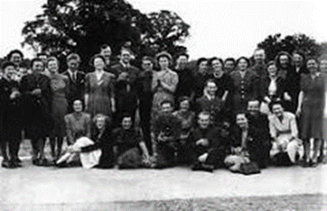

BLETCHLEY PARK
When Alan joined whilst the war was happening, he decided to join a group of codebreakers called GC and CS. They helped Alan Turing develop the Turing Machine. This machine was the key to wining the war. It could read the German codes which the Nazis sent to each other. Now let’s step away from Alan Turing. We are now going to focus on Bletchley Park.
Bletchley park stationed codebreakers called cryptographers. They were responsible for decoding complicated German codes and messages. In early development, Bletchley Park was a mansion in which people could go on holiday in. Later, the mansion was used by codebreakers during war time to decipher enemy codes. With out these people Britain would have lost the war.

